Andrew Jalbert

CSCI 230 SP17

Professor Yau

19 February 2017

Project 1 Write Up

Running Times of Methods:

move() – The move method found in the Board class has a big O function of O(n). I believe this to be true because the move function contains one iterative loop that runs from n-1 to 0. Therefore, this makes the move function O(n).

add() – The add method found in the Scoreboard class has a big O function of O(n). I believe this to be true because the add function, at the worst, must transverse the entire list. This will take n times, where n is the size of the list.

remove() – The remove method found in the Scoreboard class has a big O function of O(n). I believe this to be true because the remove method contains two for loops, but they are not nested. These two for loops works with each other. The second loop starting point is the ending point of the first loop. Therefore, I believe the method’s worst running time is O(n).

Screenshots:

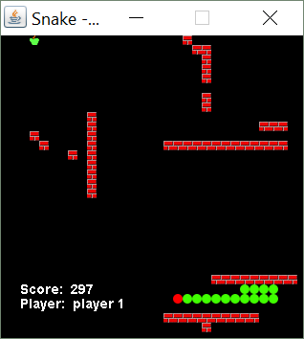

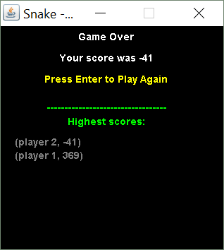

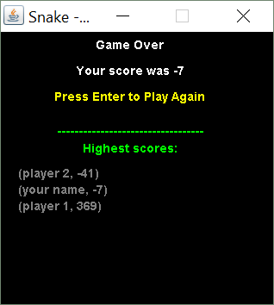

Project Discussion:

Overall, I enjoyed this project. I learned how to implement a user defined data type, how runtime works and affects a program, and how to manage memory allocation. However, I did encounter some problems. At the start of the project, I was receiving a null pointer exception. This was due to not allocating the singly linked list that represented the snake. A null pointer exception error was very common in this project. To work around this, I would write down the code on my paper and go through each step. I made sure to fully understand each step, and this was how I started to encounter less null pointers. Another problem I had with the project was implementing the scoreboard as a linked list. The issue came when I needed to print add to the linked list. Again, I wrote down each step on paper. This helped me understand what I needed to code, and how to implement it.

I found this project to be difficult. It was difficult for me because I am not familiar with Java, nor am I experienced with memory allocation. To overcome this, I used online forums to find solutions to problems I had. This helped me understand the syntax of Java, and how to implement my classes and their need for memory allocation.